
Probe Audit Premium+


Probe Review


Probe Compilation

What’s new 2023.20.13

Index

1. Caseware Working Papers 2023 4
1.1 Features 4
1.1.1 History and milestones 4
1.1.2 IDEA integration 4
1.1.3 Imports and exports 4
1.1.4 Interface 4
1.1.5 Print and save 4
1.2 Fixes 4
1.2.1 CaseView 4
1.2.2 Compression 4
1.2.3 Hybrid Cloud 4
1.2.4 Imports and exports 5
1.2.5 Interface 5
1.2.6 Copy Components 5
1.2.7 SmartSync 5
1.2.8 XBRL 5
2. Lockdown, clean up and year end close process 6
2.1 Lockdown process 6
2.1.1 Considerations before the lockdown and archiving of client files 6
3. Universal 7
3.1 Engagement history 7
3.2 Features 8
3.2.1 CaseView security levels 8
3.2.2 Sign-off functionality 8
3.2.3 Use of another practitioner (Template document 12.26) 8
3.2.4 Firm Policies 8
3.2.5 Partner & EQ Reviewer Sign off automation 10
3.2.6 Rebuttal of presumed fraud risks related to revenue recognition 11
3.3 Previously reported items fixed with Hotfixes 12
3.4 Known matters 14
3.4.1 Cosmetic items 14
3.4.2 Functionality 14
4. Audit 15
4.1 ISA 220 (Revised) 15
4.1.1 Responsibilities of the auditor 16
4.1.2 Responsibilities of the engagement partner 19
4.2 ISQM2 22
4.2.1 12.40 Engagement Quality Review – Planning (NEW) 23
4.2.2 02.80 Engagement Quality Review – Execution and finalisation 24
4.2.3 Assist with documentation of audit evidence 24
4.3 ISA 315 (2019 Revised) 24
4.3.1 Type of risk assessment procedures 24
4.3.2 Preliminary analytical review 25
4.3.3 Procedures required by International Auditing Standards 26
4.3.4 Testing compliance with laws and regulations - General 27
4.3.5 Testing compliance with Value Added Taxation Act (South Africa) 31
4.3.6 Testing Compliances with Companies Act (South Africa) 32
4.3.7 Disclosure items 32
4.4 Going concern conclusion – insufficient audit evidence 32
4.4.1 02.20 Going concern conclusion 32
4.4.2 02.50 Consideration of assurance reports 33
4.5 IAS 1 34
4.6 Supplementary or other unaudited information 34
4.7 Other 36
4.8 Probe Work programs 36
5. Review 37
5.1 ISQM2 Engagement Quality Reviews 37
5.2 Going concern conclusion – insufficient evidence 37
6. Compilation 38
7. Updated document summary 39

Caseware Working Papers 2023
The following describes the features and fixes included in Working Papers 2023 and related products.

Features

History and milestones
Added a history event for manually relocking a previously locked down engagement file. You can enable tracking for this event in your file’s history settings.

IDEA integration
Template authors can now embed IDEA analytics from their installed IDEA SmartAnalyzer workflows into CaseView paragraphs, enabling them to standardize which tests to run and when. Users can perform analytics on the engagements and receive results without having to leave the Working Papers interface.

Imports and exports
- Working Papers now supports imports from the following software packages:
  - Sage 50 Accounts 2023 (UK)
- Working Papers now supports exports to the following software packages:
  - ProFile 2022 (Canada)

Interface
- The Caseware Cloud search menu in the Consolidation | Properties, Consolidation | New | Existing File, Connect to SmartSync Copy... and Locate Parent of... dialogs has been modernized to improve performance and functionality.
- The SmartSync Server menu on the Working Papers File | Open page can now be automatically hidden when you connect to a Caseware Cloud site.
- Improved the wording in the Rename File confirmation dialog to clarify that Cloud-integrated files can be renamed, but Cloud-published files cannot.

Print and save
When exporting a CaseView document that contains external documents to a PDF, the PDF copies of the external documents can now be read by a screen reader and the text can be copied and pasted.

Fixes

CaseView
- Fixed an issue where text copied from external PDFs in CaseView would appear distorted when pasted into other text editors.
- Fixed an issue where document sections with a sort group name that exceeds 256-characters would cause the document to stop responding.

Compression
Fixed an issue that prevented some files with special characters in the file name from being compressed.

Hybrid Cloud
- Fixed an issue where Cloud-integrated files with accented characters in the file name would fail to open when a sync copy was downloaded from the File | Open | Caseware Cloud menu.
- Fixed an issue (Error code: 0x8007001d) that prevented Cloud-integrated engagement files from being converted from the Working Papers interface.
- Fixed an issue where the Year-End Close Performed column in the Working Papers app on Cloud would not update with the correct year-end close status for each file.

Imports and exports
- Fixed an issue where imports from Fortune Acomba would exclude some transactions if Use the posting date if it is different than the effective date was selected.
- Fixed an issue that prevented the completion of E-conomic Online Accounting imports.

Interface
- Fixed an issue where upon opening an engagement file, the messages “Updating balance sheet account balances” and “Processing registration” would display, but not progress, preventing access to the file’s contents.
- Updated Chromium Embedded Framework to version 109.

Copy Components
- Fixed an issue where entering an incomplete source file path in the Copy Components Wizard would cause Working Papers to crash.

SmartSync
- Fixed an issue where after uncompressing a compressed sync copy, it would attempt to synchronize with the original parent file even if it was abandoned. This was potentially causing the sync copy to synchronize with two different parent files.
- Fixed an issue where temporarily losing an internet connection would cause a connection error in active sync copies, rather than switching to the Offline status. The sync copies would only reconnect to Cloud after restarting Working Papers.
- Fixed an issue that prevented users from opening sync copies after the parent entity was moved to another business unit.

XBRL
- Fixed an issue that prevented the XBRL taxonomy from loading and reporting error HTTP 300.

Lockdown, clean up and year end close process

Lockdown process
With lockdown, you lock all documents in a client file at a point in time. At the time of lockdown, Working Papers creates a permanent copy of all locked documents. In a locked down state, all locked down documents and most shared data in the file are read-only.

Only authorised persons should perform the lockdown. To restrict rights to the lockdown consider the Protection setup and rights allocations to users.

Considerations before the lockdown and archiving of client files
When using the Lockdown Wizard Caseware Working Papers will detect whether:
- a Year end close has been performed and/or;
- whether a Clean-up has been performed on the client file selected to be locked down.

Generally, a lockdown is done after a defined period after signature of the relevant assurance report. To assist firms with remembering to schedule their file lockdown, we have included a Schedule lockdown button in the Information Store document where the report date is set to remind users to perform or schedule the lockdown.

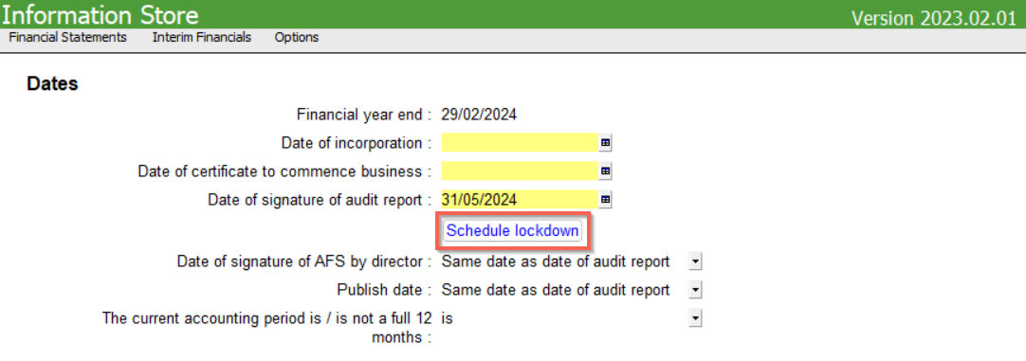

Universal

Engagement history
We have added a folder in the document manager called Engagement History. 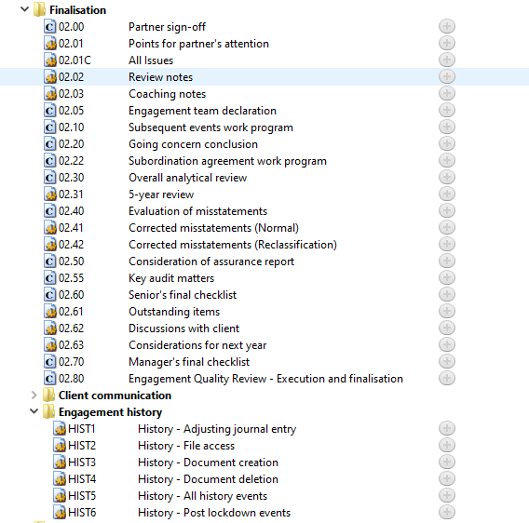

In this folder we created automatic documents that will enable you to see the history per engagement and these automatic documents are the following:
- Adjusting journal entry
- File access
- Document creation
- Document deletion
- All history events
- Post lockdown events

Features

CaseView security levels
The CaseView levels changed as follows:

Description | 2022.20.13 | 2023.20.13
System administrator | 10 | 9
Practitioner / Partner | 9 | 8
Senior Manager | 8 | 7
Manager | 7 | 6
Junior Manager | 6 | 5
Accountant in charge | 5 | 4
Senior | 4 | 3
Semi Senior | 3 | 2
Junior | 2 | 1
Read only access / No access rights | 1 | 0

Sign-off functionality
A new feature had been added to the team members, engagement partner and engagement quality reviewer declarations in the related documents, where only the logged in user can sign off where their name has been selected from the dropdown list.

When the user’s name is the same as the name selected from the dropdown, a pen icon should appear at the end of the row, which will then allow the user to sign-off. The sign off cannot be undone by anyone other than the correct user.

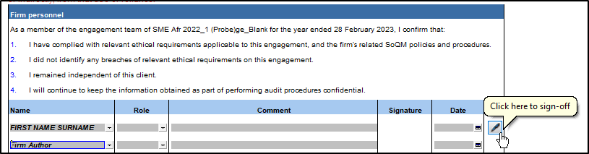

Use of another practitioner (Template document 12.26)
A new document has been added to the document manager, this document is a template document and needs to be printed out and completed manually, this document can be sent to another practitioner to complete.

Firm Policies
A new feature has been added to the Probe Firm Settings and related documents, that allows firm authors to add firm mandatory procedures. Some firms’ might specify significant judgments or significant matters, in their firm’s System of Quality Management (SoQM) policies and procedures, whose audit evidence shall be reviewed by engagement partners.

To activate this, the firm author should log in on a level equal to or higher than indicated for the setting:
“Minimum level of staff members that can set firm policies”:
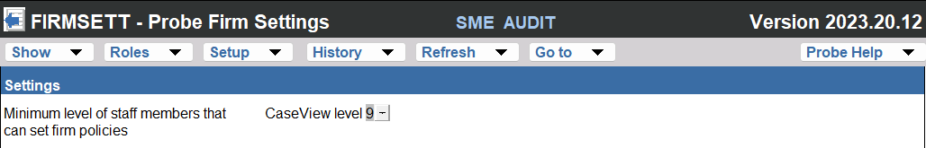

A new section will then be enabled on relevant documents:
- 10.80 - Engagement Quality Review – Planning (Review)
- 12.40 - Engagement Quality Review – Planning (Audit)
- 12.30 - Planning memorandum
- 02.80 - Engagement Quality Review - Execution and finalisation
- 02.00 - Partner sign-off

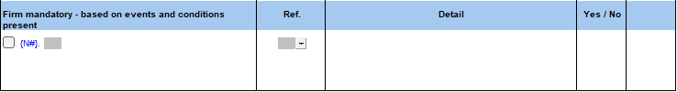
Only the firm author can add procedures to this section and when the template is released, can delete procedures added in this section. Other users will be able to add additional procedures, provided the firm author has created one or more procedures but they will not be able remove anything created by the firm author.

Users will use the selection box to indicate if the procedure is relevant for execution or not.

Partner & EQ Reviewer Sign off automation
To assist partners and EQ Reviewers when they review files electronically, we have developed a new feature that can automate references to documents already reviewed for Partners and EQ Reviewers.

The firm author can switch this feature on and off in the Probe Firm Settings by indicating the automation as “Automated” or “None”.

The firm author can also indicate the Role as which Partners and EQ Reviewers sign off for their firm in the default role sets.

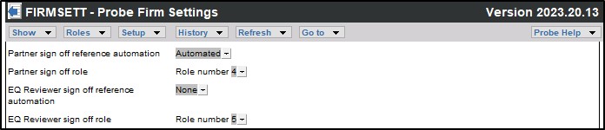

The documents that include the new reference automation are:
- 10.80 - Engagement Quality Review – Planning (Review)
- 12.40 - Engagement Quality Review – Planning (Audit)
- 12.30 - Planning memorandum
- 02.80 - Engagement Quality Review - Execution and finalisation
- 02.00 - Partner sign-off

When the sign off reference automation is selected as “Automated”:
The document referenced will pull through the relevant sign off role and date.

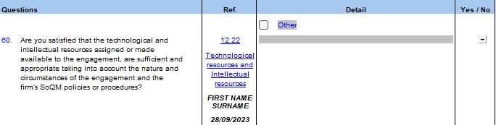
Please note that the sign-off for the specific document selected as reference will reflect here, no additional sign-off will occur when selecting Yes / No as the Engagement partner declaration / Engagement Quality Reviewer declaration will act as final sign off of the procedures reviewed.

When the sign off is automation is selected as “None”:
No sign off or date will be displayed.

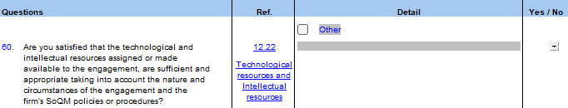

Rebuttal of presumed fraud risks related to revenue recognition
A new feature has been added to document 11.60 – Risk assessment at assertion level. In the previous versions of document11.60 - Risk assessment at assertion level has had default presumed risks in the revenue and investment income sections. These risks will still exist in the released version and will now include a new question as part of risk assessment that will require you to conclude on the applicability of the presumed risks for your engagement.

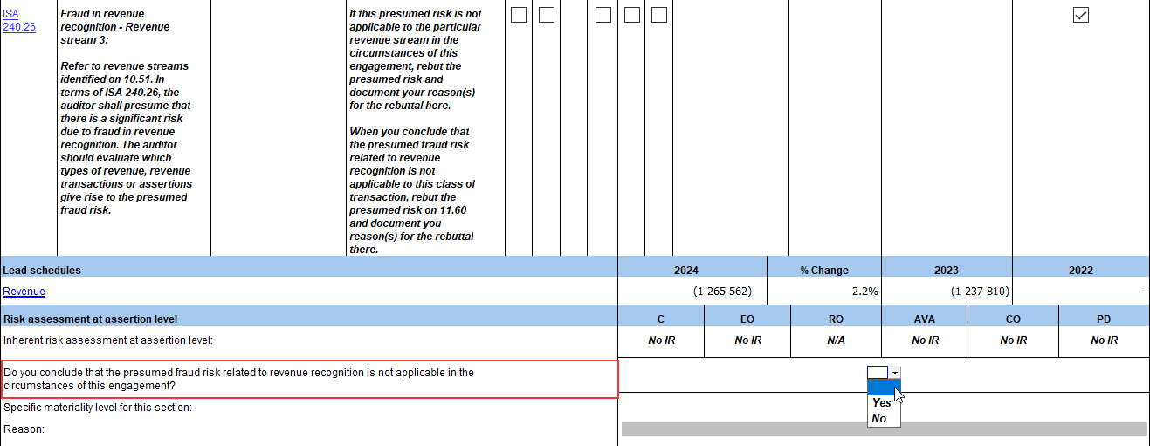
Should you select “No” in the dropdown or leave the question unanswered, your presumed risks will remain and you may continue to document as per existing functionality. Should you select “Yes” in dropdown, all presumed risks for that section will be removed and a space for documentation will appear below the above-mentioned question so that you may explain your reasons for rebuttal.

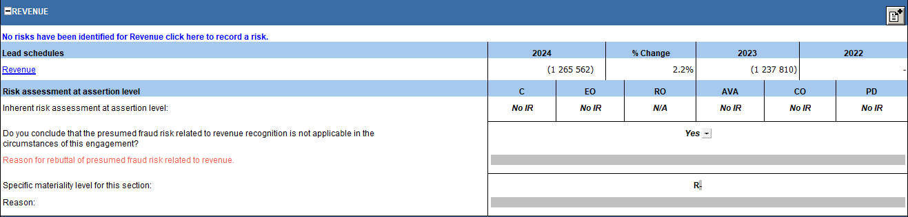

Previously reported items fixed with Hotfixes
https://success.casewareafrica.com/articles/Knowledge/Probe-Hotfix
The following list is a brief description of fixes that have been made though hotfixes:

Groupings
- The leadsheets for the section Deferred tax liability does not show any balances.
- The leadsheets for the section Loans to/from group companies have variances in comparison with the annual financial statements.

Caseware Q
Adds a button to the toolbar for you to trigger the sync of Q information in the file with Caseware Cloud.

07.500 Non-current liabilities compilation program
Conclusions are linked to each other.

10.50 Gathering information
References are linked to each other.

10.51 Types and volumes of transactions
- The selected source documents in the Revenue section for the question "Where does a sales transaction originate for different categories of revenue" are not consistent with the source documents being displayed in the work program.
- The reference cells in each section are not populating correctly when linking documents on that cell.
- The operating expenses section leadsheet's total does not add up correctly with its respective sub-categories.
- The responses in the 'Types of procedures' table are linked.

10.53 Understanding of accounting estimates.
The user cannot access the section for Investment Property at fair value when using the link from 10.51 Types and volumes of transactions.

11.20 Inherent risk assessment
- The conclusion section does not populate automatically, causing further issues in 11.10 Risk analysis summary where the risk assessment remains as not yet assessed.
- Overall responses selected when recording a risk are not pulling through to the overall risk responses table.

11.25 Fraud risk assessment
- Inserting a new row for additional considerations and procedures does not work.
- The conclusion section does not populate automatically, causing further issues in 11.10 Risk analysis summary where the risk assessment remains as not yet assessed.
- The tickboxes for significant risks do not get ticked automatically. After applying this hotfix, you will need to re-assess all your risks (in documents 11.20, 11.25 and 11.30) by editing the risks, marking them as significant, if required, and then submitting.
- Overall responses selected when recording a risk are not pulling through to the overall risk responses table.

11.30 Evaluation of system of internal control
- Overall responses selected when recording a risk are not pulling through to the overall risk responses table.
- Inserting a new row for additional considerations and procedures does not work.
- The conclusion section does not populate automatically, causing further issues in 11.10 Risk analysis summary where the risk assessment remains as not yet assessed.

11.50 Information system and control activities
- Linking of a control to a risk will now be possible for all sections after a control was removed by erasing the Control ID instead of removing it by selecting a blank control.
- A new line cannot be added under the General IT controls section once all risks are deleted.
- Adding a new control creates two controls instead of one (the desired control and a blank control). ￼
- Performing walkthrough procedures is always a requirement even when having selected that walkthroughs are not a requirement in either the Firm Settings or in 10.50 Gathering Information.
- The overall conclusion consideration shows all the time instead of only showing when the user has determined the overall conclusion to be 'Inappropriate'.
- The inherent risk column of the controls to address risks, does not populate automatically.

11.60 Risk assessment at assertion level
The default presumed risks of fraud recognition in the Revenue and Investment Income sections cannot be used for additional sections. You will now be able to edit those risks and link them to other sections.

12.20 Audit plan and strategy
The risk assessment at financial statement levels and the overall response increase extent of work on all relevant and selected assertions, are not populating automatically from 11.20, 11.25 and 11.30.

Work programs
- Rectifies an issue where, after running the hotfix, the user is unable to insert hidden procedures that they have chosen to show in the work programs.
- Work programs for review engagement where sections are not material and have no items likely to be misstated during the planning phase but where the user reassesses that there are items likely to be misstated during the execution phase do not populate for that work program.
- Work programs for review engagement where sections are not material and have items likely to be misstated during the planning phase where the user determines in the work program that the financial statements are still likely to be materially misstated does not bring in the required procedures.
- Work programs for audit engagements where the procedure 'Have you, during the audit, identified adjustments which result in this section being material?' appears even when the assessment and the procedures have been completed correctly.
- The assertions for significant risks in 11.60 and the assertions for those same significant risks in the work programs are not aligned.

700.10 Revenue work program
The audit procedures for the assertion Cut-off (CO) are erroneously shown under the assertion Accuracy, Valuation and Allocation (AVA).

Other work programs
These work programs open as blank and do not populate the required procedures and information:
- 405.11 Attendance at physical inventory count work program
- 420.11 Cash count work program
- 430.11 Receivables direct confirmation
- 430.61 Receivables confirmation summary
- 750.11 Wage payout work program
- 750.60 Director's remuneration certificate

02.00 Partner sign-off
Whenever the user raises a significant risk at assertion level (11.60), it does not reflect in the document (Summary at assertion level).

Known matters

Cosmetic items

Work programs
- When revising your audit plan in the work program, the overridden dot appears
- Within the following sections, the last procedure in the section is not an input cell:
  - Extended test of detail
  - Substantive sampling

Printing
- 02.20 - The document number appears misaligned on the bottom left of the page.

10.70 - Identify material items and areas likely to be misstated
- When raising a new LTBM, the details of the LTBM recorded correctly appears, but each time a Blank LTBM also appears. Simply deleting it will solve the issue.

Update
- In the Protection setup, EQR will refer to the old term of EQCR as we are unable to access our users’ data stores to amend this.
- In the document manager, not all folders are collapsed.

Functionality
Description | Description of matter | Alternative
Community links
Links for assistance | When clicking links for assistance, the webpage gives an error. | No workaround, community will be updated shortly
Update
Work programs | Data retention – Revised audit plan, the information does not retain after update. | No workaround
11.50 Information system and control activities
Deleted controls in control dialog | When deleting a control by pressing the “delete” button in the control record mode dialog, the control is still recorded. | Any blank controls can be deleted
Probe firm settings
Drop down selections | The dropdown selections are not auto-saving. | Users can save the document manually.

Audit

ISA 220 (Revised)
This release includes changes related to ISA 220 (Revised), Quality Management for an Audit of Financial Statements, together with the conforming amendments to other international standards, effective for audits of financial statements for periods beginning on or after 15 December 2022.

Major changes to ISA 220 (Revised) include:
- Clarification of the required involvement of the engagement partner throughout the audit and for managing and achieving quality on the audit, which include the standback-requirement at the end of an audit.
- Changes to the definition of “Engagement team” that recognise that:
  - Engagement team could include individuals from another firm, for example to perform inspection of physical fixed assets or performing inventory count.
  - Regardless of the location of employment status, the individuals need to be independent, and their work needs to be appropriately directed, supervised, and reviewed.
- Clarification that in certain circumstances the engagement partner may depend on the firm’s policies or procedures in complying with ISA 220 (Revised) and should not ‘blindly’ rely on the firm’s System of Quality Management (SoQM) without taking into account whether the firm’s SoQM policies or procedures are fit-for-purpose in the specific circumstances of the engagement.
- Emphasizing that each engagement team member must exercise professional scepticism and recognise that conditions in some audits can create impediments to appropriate exercise of professional scepticism.
- Requirements to address the full suite of resources needed at engagement level, being human, technological, and intellectual resources. The engagement partner needs to take action if the resources made available is not sufficient or appropriate in the circumstances of the engagement.
- Determination whether the engagement team, including any auditor’s external expert and internal auditors who provide direct assistance, collectively have the appropriate competence and capabilities, including sufficient time, to perform the engagement.

We added and amended the following documents in terms of this standard:
- Amendments
  - 12.30 – Planning memorandum
  - 02.00 – Partner sign-off
- Additions
  - 12.22 – Use of resources
  - 12.26 – Use of another practitioner
  - 02.05 – Engagement team declaration

Responsibilities of the auditor
Matter identified | ISA ref | Comment
10.50 Gathering information
Firm’s monitoring and remedial process | ISA220.39 (a) | Question added to determine whether any matter or deficiency identified through the firm’s monitoring and remedial process is relevant to the engagement.  When answered ‘Yes’, the engagement team will be prompted to document actions to address identified matters, including consideration to amend the audit plan and strategy on 12.20 (red warning).  In FIRMSETT it can be elected whether your firm is part of a network. The wording of the procedure will be amended to either include or exclude network and network firms. The default setting in FIRMSETT is “No”.
12.10 Manager planning checklist
ISA220: Quality Management for an Audit of Financial Statements | ISA220.17  ISA220.25  ISA220.26 | Manager to conclude whether documented audit evidence provide evidence that:  - The engagement team have been made aware of the relevant ethical requirements.  - The resources assigned or made available are sufficient and appropriate.  - The engagement team collectively have appropriate competence, capabilities, and sufficient time.
12.20 Audit plan and strategy
Professional scepticism | ISA300  ISA220.7, ISA220.13 ISA220.14 | ISA300 requires the engagement team to determine the actions needed to mitigate the impediments to the appropriate exercise of professional scepticism when developing the overall audit strategy.  Therefore, questions are to identify conditions and unconscious or conscious biases that may impede the appropriate exercise of professional scepticism.  When identified extended users are prompted to document actions taken to mitigate the impediments.
12.22 (NEW) Use of resources
The objective of the document is to:
- Assist the engagement team to evaluate whether the resources are sufficient and appropriate to perform the engagement, and
- Enable the engagement partner to conclude, based on the documented evidence, whether the resources are sufficient and appropriate (ISA220.25-28), including whether the engagement team collectively have the appropriate competence, capabilities, and sufficient time (ISA220.26).
Engagement team members – Firm personnel declaration | ISA220.14  ISA220.17  ISA220.26 | The declaration to be signed by firm team members moved from 12.30 to 12.22.  The wording of the declaration has been updated with requirements of ISA 220 (Revised), including expected behaviour, and awareness of ethical requirements and the firm’s related policies or procedures.  Reference to EQR has been removed since “engagement team” definition clarifies that EQR is not part of engagement team.
Engagement team members - Use of another practitioner | ISA220.14  ISA220.17  ISA220.26 | Procedures added to address the requirements of ISA 220 (Revised) related to engagement team members, including evaluating competence and capabilities, communication with regards to ethical requirements and expected behaviour.  Procedures are added based on the selection ‘Use of Another Practitioner’ in 12.20.
Use the work of auditor’s expert | ISA220.26  ISA620.8&9 | Procedures added to evaluate the competence, capabilities, and objectivity of the auditor’s expert.  Procedures are added based on the selection ‘Use of work of auditor’s expert’ in 12.20.
Technological resources | ISA220.25 | Procedures added to determine whether technical resources will be used to obtain audit evidence and if so, whether use of the technical tools are appropriate considering the firm’s policies or procedures.  For extended users, additional procedures were added (ISA220.A64-77) to assist with execution and documentation.
Intellectual resources | ISA220.25 | Procedure added to determine whether resources other than what the firm provided are required.
EQ Reviewer | ISQM2.17  ISQM2.18 | Procedures added to evaluate appropriate appointment of EQR, and eligibility of the EQR and assistants, including the cooling-off period of 1 year for previous engagement partners and sufficient time to perform the EQ review.
12.26 Use of another practitioner (NEW)
The objective of the document is to provide information to the individuals from another firm who will perform audit procedures, and to request information from that firm to finalise the audit plan and engagement.
Planning: Engagement team declaration | ISA220.14  ISA220.17  ISA220.26 | Individuals from the other firm are prompted to submit a signed engagement team member’s declaration to assist with evaluation of competence, and adherence to ethical requirements, including firm policies or procedures.
Planning: Direction, supervision, and review | ISA220.29 | Determine the nature and extent of direction, supervision and review of work performed by individuals form the other firm.
Planning: Technological resources | ISA220.25 | Determine whether the other firm will be using technological resources.
Finalisation: Engagement team declaration | ISA220.21 | The individuals from the other firm are prompted to submit a signed engagement team members’ declaration with their completed audit documentation.
12.30 Planning memorandum
Planning meeting notes: Engagement team members attending the meeting |  | The names of the team members attending the planning meeting to be documented due to the engagement team declaration moving to 12.20.
02.70 Manager’s final checklist
ISA220: Quality Management for an Audit of Financial Statements | ISA220.17  ISA220.35  ISA220.38 | Manager to conclude whether:  - Nothing comes to your attention that indicated potential breaches of relevant ethical requirements or the firm's related SoQM policies and procedures by engagement team members.  - Required consultation have taken place on difficult or contentious matters, and where applicable, whether conclusions reached have been implemented appropriately.  - Differences of opinions have been resolved, and that conclusions reached are documented and implemented.
02.05 Engagement team declaration
Firm personnel | ISA220.21 | Firm personnel sign the engagement team members’ declaration to confirm that they have complied with ethical requirements throughout the engagement, did not identify any breaches, and remained independent.
Use of another practitioner | ISA220.21 | Engagement team is prompted to obtain a signed engagement team members’ declaration from individuals from another firm.  Procedures are added based on the selection ‘Use of Another Practitioner’ in 12.20.

Responsibilities of the engagement partner

Engagement partner declarations
Matter identified | ISA ref | Comment
10.20 Engagement evaluation
Engagement partner declaration | ISA220.22  ISA220.22  ISA220.23 | With regards to client relationship and audit engagement, engagement partners to conclude whether:  - The procedures have been followed in accordance with the firm’s SoQM policies and procedures.  - Conclusion reached is appropriate.  - Information obtained should be taken into account in identification and assessment of RMM or design of audit plan and strategy.
12.30 Planning memorandum
Planning meeting notes: | ISA220.14  ISA220.14(d) | Engagement partners are prompted to:  - Communicate the expected behaviour to the team members attending.  - Discuss any conditions that may impede the appropriate exercise of professional scepticism, and biases identified on 12.20.  - Identify matters to be communicated to engagement team members not attending.
Engagement partner declaration | ISA220.14  ISA220.16  ISA220.17  ISA220.18  ISA220.19  ISA220.20  ISA220.25  ISA220.26  ISA220.27  ISA220.30  ISA220.31  ISA220.39 | The declaration has been updated to:  - Include all the ISA220 requirements that state, “The engagement partner shall”.  - Remove all the declarations not specifically required by ISA220.  - Include other ISA requirements that state, “The engagement partner shall”, for example ISA 315.17.  The format of the declaration has changes to question format based on focused enquiries to selected customers.
02.00 Partner-sign off
Engagement partner declaration | ISA220.20  ISA220.21  ISA220.31  ISA220.33  ISA220.35  ISA220.36  ISA220.38  ISA220.40 | The declaration has been updated to:  - Include all the ISA220 requirements that state, “The engagement partner shall”, as well as that of ISRE2400.  - Remove all the declarations not specifically required by ISA220.  - Include other ISA requirements that state.

Assist with documentation of rationale of conclusions

To assist engagement partners with the documentation of their rationale or basis for their conclusion related to the engagement partner “shall” paragraphs of ISA 220 (Revised) (refer ISA230. 8c read with A10), the following have been added to the declarations:

- The actions that are expected to be performed to meet the ISA 220 (Revised) requirements, when the Probe template is used, are included as options in the “Detail” column of the declaration. The inclusion of the actions will be depended on the selections made earlier in the engagement file, for example actions related to use of individuals from another practitioner will only be added when it was selected in 12.20 that another practitioner’s staff will be used.
- When an action is selected, the reference of the relevant Probe document will be added in the “Reference” column.
- The engagement partner can use the hyperlink to jump to the relevant question or section within the document or the whole document, depending on where it is expected that the relevant audit evidence is recorded.
- If electronic sign-off was chosen (refer par 3.2.5 Partner & EQ Reviewer Sign off automation), and the relevant document has been signed off by the engagement partner, the electronic signature and date will pull through to the reference column. Engagement partners can use this information to quickly determine whether they have reviewed the audit evidence to answer the relevant question.

For example, ISA 220.17 requires that engagement partners satisfy themselves that the engagement team, which include firm personnel and individuals from another practitioner, have been made aware of relevant ethical requirements applicable to the audit engagement. In the Probe template, the actions to make the engagement team members aware of the ethical requirements, is (1) asking engagement team members to sign the engagement team members’ declarations and (2) the engagement partner discussing the relevant requirements at the team discussion.

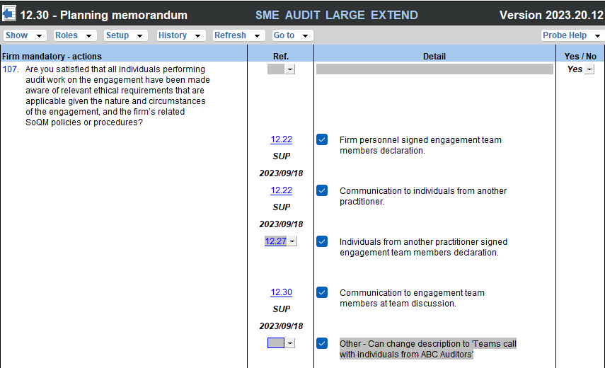

Furthermore, ISA220.30 requires engagement partners to review audit documentation related to significant matters, significant judgements, and other matters, based on the engagement partners’ professional judgement, that are relevant to the execution of their responsibilities as engagement partner. ISA 220.30 does not specify which significant matters or significant judgements should be reviewed. The application material does however provide examples. To assist engagement partners with documentation, these examples were added to the “Detail” column to select from, based on the engagement partners professional judgement and their firm’s SoQM policies and procedures:

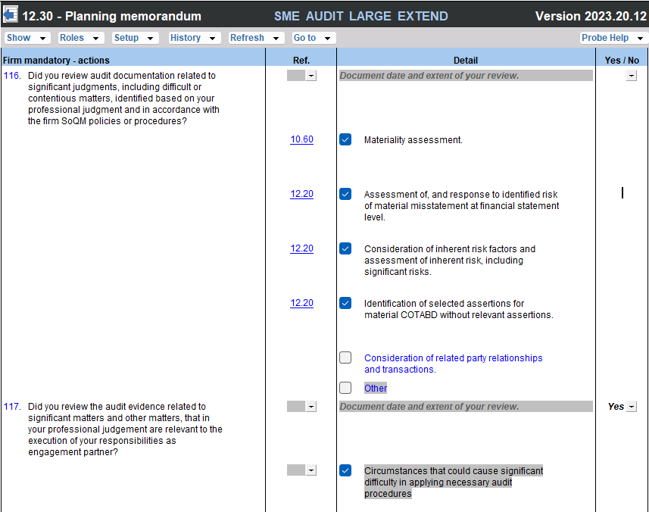

Some firms’ might specify significant judgements or significant matters, in their firm’s System of Quality Management (SoQM) policies and procedures, whose audit evidence shall be reviewed by engagement partners.

- For significant judgements or significant matters whose audit evidence should always be reviewed, firm authors can add questions to the declaration. As with other questions in the product, the user will not be able to delete questions added by the firm author.
- For significant judgements or significant matters whose audit evidence should be reviewed if certain events or conditions are present on the engagement, for example significant uncertainty related to going concern, the firm author can add questions to sub-section “Firm mandatory – based on events and conditions present”. This sub-section will only be included in the declarations when the firm author has added questions.

See par 3.2.1 CaseView security levels
The CaseView levels changed as follows:

Description | 2022.20.13 | 2023.20.13
System administrator | 10 | 9
Practitioner / Partner | 9 | 8
Senior Manager | 8 | 7
Manager | 7 | 6
Junior Manager | 6 | 5
Accountant in charge | 5 | 4
Senior | 4 | 3
Semi Senior | 3 | 2
Junior | 2 | 1
Read only access / No access rights | 1 | 0

Sign-off functionality
A new feature had been added to the team members, engagement partner and engagement quality reviewer declarations in the related documents, where only the logged in user can sign off where their name has been selected from the dropdown list.

When the user’s name is the same as the name selected from the dropdown, a pen icon should appear at the end of the row, which will then allow the user to sign-off. The sign off cannot be undone by anyone other than the correct user.



Use of another practitioner (Template document 12.26)
A new document has been added to the document manager, this document is a template document and needs to be printed out and completed manually, this document can be sent to another practitioner to complete.
Firm Policies on details of how this feature works.

ISQM2
The requirements of ISQM2 Engagement Quality Review, effective for audits and reviews of financial statements for periods on or after 15 December 2022, are addressed in this release. The changes in ISQM2 are intended to:

- Extend the scope of engagements subject to an EQ Review (“EQR”).
  - Audits of financial statements of listed entities.
  - Audit or other engagements for which and EQR is required by law or regulation.
  - Audits of other engagements required by the firm’s SoQM policies and procedures,
  - Appropriate response to address one or more quality risk(s).
- Strengthen the eligibility criteria for an individual to be appointed as an Engagement Quality Reviewer (“EQ Reviewer”); and
- Enhance the EQ reviewer’s responsibility relating the performance and documentation of an EQR.

The revised requirements focus on the objective evaluation of significant judgements made by the engagement team and the conclusions reached thereon.

ISQM2.24 requires that the EQR perform procedures at appropriate time during the engagement. Some of the procedures the EQR is required to perform, for example reading and obtaining and understanding of the nature and circumstances of the engagement and entity, should be performed during planning. To facilitate timeous execution of required procedure, the Engagement Quality Review checklist is split in two, one for planning and one for execution and finalisation.

The design of both documents took into account that engagement quality reviews can be performed by both external and internal EQ Reviewers.

We added and amended the following documents in terms of this standard:
- Amendments
  - 02.80 – Engagement Quality Review – Execution and finalisation
- Additions
  - 12.40 – Engagement Quality Review - Planning
  - 02.05 – Engagement team declaration

12.40 Engagement Quality Review – Planning (NEW)
12.40 includes questions related to those procedures that the EQR are expected to perform at planning stage, including:
- Reading the firm’s relevant SoQM policies and procedures (ISQM2.18(b) & 20(b) & 21 & 22 & 24).
- Considering and concluding on eligibility to act as EQ Reviewer (ISQM2.23)
- Obtaining understanding of engagement and entity (ISQM2.25) as well as results from the firm’s monitoring and remedial action process (ISQM2.25)
- Having required discussions with engagement partners and where appropriate other engagement team members (ISQM2.25(b)).
- Review of audit evidence relating to significant judgements made by the engagement team during planning (ISQM2.25(c))

Matter identified | ISQM ref | Comment
EQR assistants |  | The EQ Reviewer will record whether assistants will be used to perform the EQR.  When assistants are used, questions will be added to prompt the EQ Reviewers to execute their responsibilities with regards to work performed by the assistance, for example determining what the firm’s policies or procedures are related to the nature, timing and extent of direction and supervision by the EQ Reviewer.  The description of questions will also be amended to extent the action to the assistants.
EQ Reviewers declaration | ISQM2.20  ISQM2.30(a) | The EQ Reviewer and assistants to complete a declaration to record their experience as evidence of the competence and capabilities as EQ reviewers.  The documented evidence can be used to conclude on the eligibility of the EQ Reviewer and assistants in accordance with the firm’s SoQM policies or procedures.  As noted in par 4.1.1, the EQ Reviewers do not sign the Engagement Team Members’ declaration as they are not deemed to be part of the engagement team.
Significant judgements and matters | ISQM2.25 (c) | Refer par 4.2.3 below

02.80 Engagement Quality Review – Execution and finalisation
02.80 has been updated with questions that prompts the EQR to perform actions to address the requirements of ISQM2.

Assist with documentation of audit evidence
Read with par 4.1.2.2.

To assist the EQ Reviewers with the documentation of which audit evidence related to significant judgements were reviewed by the EQ Reviewers, an “Other” option has been included in the “Detail” column”. EQ Reviewers can:

- Record the description of the significant judgement.
- Link to the document or working paper reviewed.

If electronic sign-off was chosen (refer par 3.2.5 Partner & EQ Reviewer Sign off automation), and the relevant document has been signed off by the EQ Reviewer, the electronic signature and date will pull through to the reference column. EQ Reviewers can use this information to quickly determine whether they have reviewed the audit evidence to answer the relevant question.

The firm author can add mandatory procedures to the checklist and can add mandatory firm – based on events or conditions.

ISA 315 (2019 Revised)
Following the implementation of ISA 315 (2019 Revised) and conforming amendments, we visited customers to obtain feedback on the implementation of ISA 315 (Revised) using the Probe 2022 release. The following changes resulted from those post-mortem meetings:

Type of risk assessment procedures
In the Probe 2022 release, the type of risk assessment procedures (“RAP”) are documented per class of transactions, account balance and disclosure item (“COTABD”) on 10.51 Types and volumes of transactions. Customers advised that in several instances the type of RAP performed will be the same for all COTABD. In these instances, there is duplication of effort due to similar information being documented repeatedly.

To improve efficiencies the firm authors can now elect in FIRMSETT Probe Firm Settings whether engagement teams should record the type of RAP individually per COTABD or once on 10.51. The election can be done for all audits or per audit engagement. The default setting is “Elected per audit engagement”.

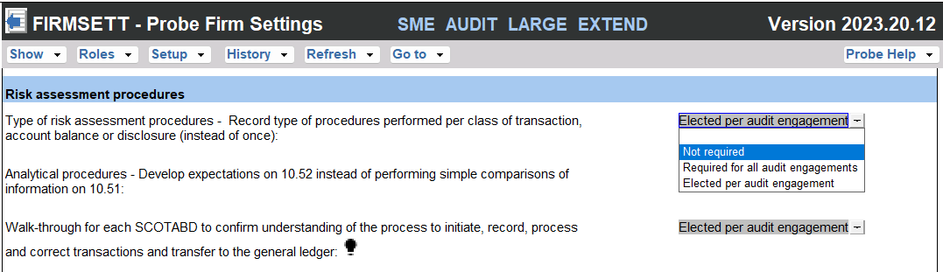

When the election should be done per audit engagement, a question will be included in 10.50 Gathering information “Do we plan to record the type of risk assessment procedures performed for each class of transaction, account balance or other disclosure separately?”.

Preliminary analytical review
The preliminary analytical procedures were moved from the work programs to 10.51 in the Probe 2022 release to assist with identifying and assessing risks of material misstatement during planning. Customers advise that there is some confusion when they should use 10.52 Preliminary analytical review and when they should complete the basic analytical procedures under “Identify possible ROMM” on 10.51. This confusion could lead to duplication of effort and inconsistencies in the audit file.

The firm authors can now elect in FIRMSETT Probe Firm Settings, based on the firm’s methodology, whether engagement teams should develop expectations for analytical procedures on 10.52 or use 10.51 to perform simple comparisons of information on 10.51. The default setting is “Elected per audit engagement”.



When the election should be done per audit engagement, a question will be included in 10.50 Gathering information “Do we plan to use 10.52 to perform analytical procedures to identify and assess risk of material misstatement instead of performing simple comparisons of information on 10.51?”.
When it is elected to develop expectations on 10.52, 10.52 will be included in the audit file and the analytical procedures on 10.51 will be excluded from 10.51. When it is elected to perform simple comparisons of information on 10.51, 10.52 will be excluded and the analytical procedures on 10.51 will be included.

Procedures required by International Auditing Standards

General

Some procedures, for example those procedures that are required to be performed when substantive sampling is selected as audit response, does not provide audit evidence independently. It will be performed in conjunction with another test of detail. Furthermore, these procedures are required to be performed in accordance with an ISA, either:
- Always, for example agree the amounts and disclosures presented in the current period financial statements to underlying accounting records, or
- when decisions are taken by the engagement team, for example an auditor’s expert will be used or sampling will be part of the audit response.

In the 2022 and earlier Probe releases, all assertions were assigned to this category of procedures.

With the implementation of ISA 315 (2019 Revised) together with the conforming amendments to ISA 330, only relevant and selected assertions are tested. The assignment of all assertions to this category of procedures, could be confusing or misleading to the users.
To make it clearer that these procedures should not be considered in the conclusion whether sufficient and appropriate audit evidence has been obtained for the relevant and selected assertions, the following changes have been made:
- All assertions have been removed from this category of procedures.
- The relevant ISA reference has been added to inform users that it is a required procedure in accordance with which ISA (subject to selections made by the engagement team).

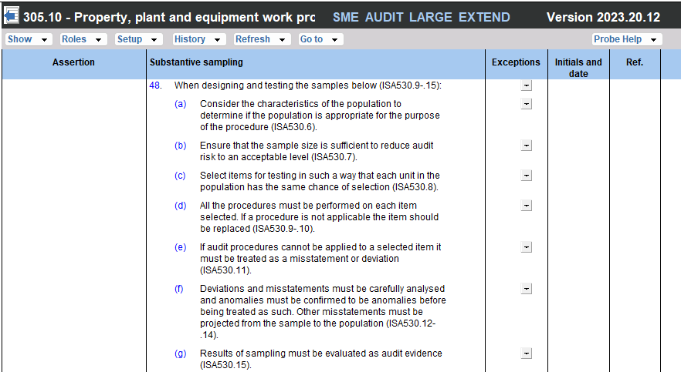

Other examples included in this category of procedures are procedures related to:

- Agree the amounts and disclosures presented in the current period financial statements to the following and reconcile any differences (ISA330.20 and .30).
- Substantive analytical procedures (ISA520.5 & 7)
- Using the work of a management’s expert (ISA500.8 &9)
- Using the work of an auditor’s expert (ISA620.10)
- External confirmations (ISA505)

Material inventory

Irrespective of the engagement team’s determination of relevant or selected assertions for inventory, ISA 501.4 requires the engagement team to attend an inventory count, unless impracticable, for material inventory.

To prompt the auditor to consider attending an inventory count for material inventory, a red warning has been added to 12.20 Inventory section – refer screenshot below.

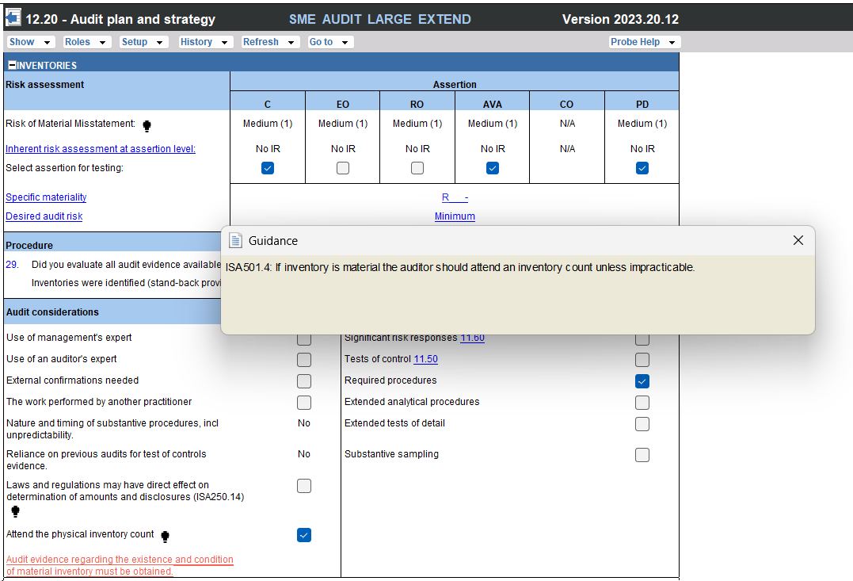

Testing compliance with laws and regulations - General

ISA 250.14 requires that the “auditor shall obtain sufficient appropriate audit evidence regarding compliance with the provisions of those laws and regulations generally recognized to have a direct effect on the determination of material amounts and disclosures in the financial statements.”

There is a risk that the engagement team does not take this requirement of ISA 250.14 into account when identifying and subsequently testing relevant and selected assertions. Prior to the 2022 release, engagement teams would have tested all assertions related to material transactions and balances.

To prompt the auditor to test compliance with provisions of laws and regulations that may have a direct effect on the determination of material amounts and disclosures, the following changes have been made:

11.21 Laws and regulations.

The engagement team will continue to identify laws and regulations into the three categories. Before the 2022 release, engagement teams would have reviewed and amended the work programs whilst completing 11.21 Laws and regulations. From the 2022 release, following the implementation of the ISA315 (2019 Revised) changes, the work programs will not be populated with audit procedures when 11.21 is completed, since not all relevant or selected assertions would have been recorded or selected. Selected assertions are those assertions selected for a material COTABD without inherent risks. The work programs are populated with relevant procedures only for COTABD with relevant and selected assertions. Populating the work programs with audit procedures are finalised with the completion of 12.20 Audit plan and strategy.

Therefore, the auditor is now referred to 12.20, instead of to the work programs, to

Firstly, identify the COTABD whose determination of material amounts and disclosures may be affected by the provisions of the identified laws and regulations, and
- Review the work program of those COTABD to obtain sufficient and appropriate evidence regarding the compliance.

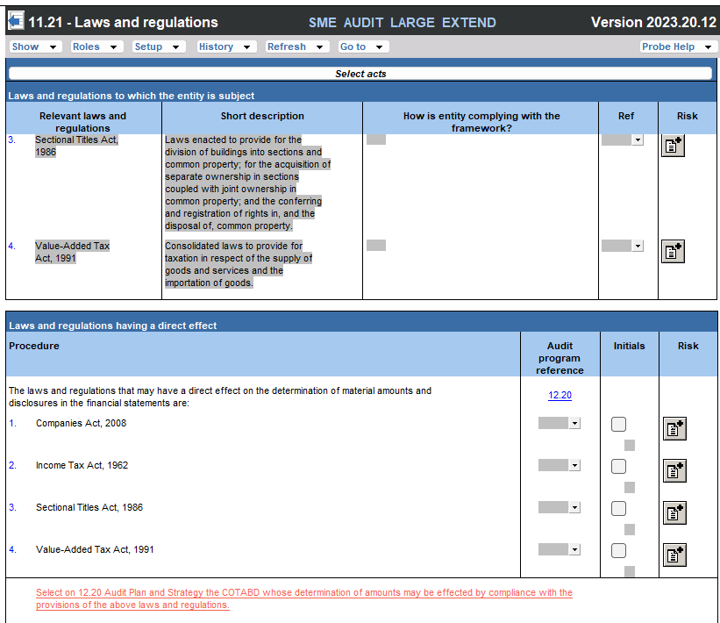

A red warning is added as reminder of action required:

12.20 Audit plan and strategy

In 12.20 a new consideration “Laws and regulations may have direct effect on determination of amounts and disclosures (ISA250.14)” was added to each section. The auditor should consider per section whether the laws and regulations identified on 11.21 may have a direct effect on the determination of material amounts and disclosure of that section. If answered yes, a required audit response, namely ‘Required procedures – Laws and regulations” will be added under “Audit procedures”. This audit response will be auto ticked.

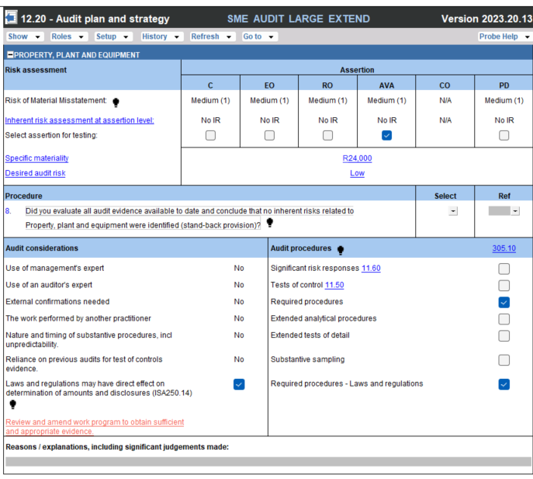

The work program will only be activated when relevant or selected assertions have been identified. Therefore, these compliance procedures will always be included in a work program for a material COTABD and a COTABD with a relevant assertion.

When the auditor has not yet recorded an inherent risk for an immaterial COTABD, based on the section’s specific materiality, a red warning will appear prompting the auditor to record an inherent risk. It is expected that when the auditor concludes that an identified law or regulation may have a direct and material effect on the determination of amounts and disclosure of an immaterial COTABD, the auditor will respond by recognising an inherent risk and relevant assertion.

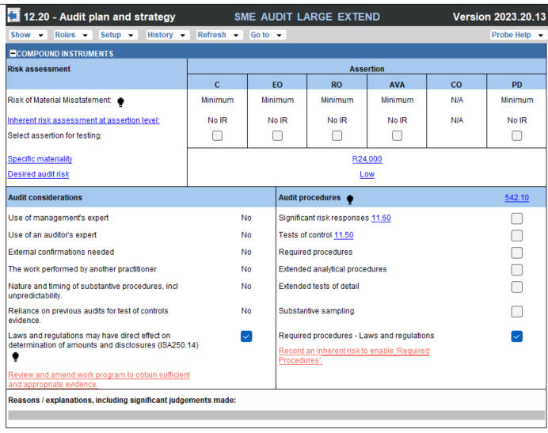

When the auditor has selected “Required procedures – Laws and regulations” for a COTABD, the relevant work program will include a prompt for the auditor to add audit procedures to test compliance with the identified law or regulation.

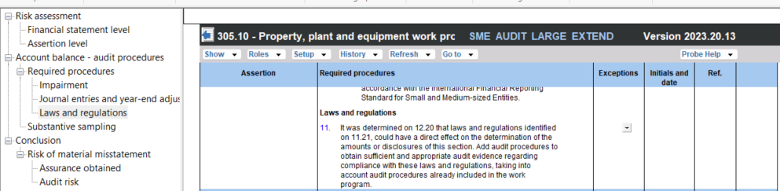

When the auditor did not identify a law or regulation that may have a direct effect on the determination of material amounts and disclosure of a COTABD during planning, but during execution evidence indicate that there is such a law or regulation, the auditor can revise the audit plan. In the conclusion, the auditor
- Answer “Yes” to “A need to revise audit plan?”.
- Select “General including laws and regulations.”
- Select “Required procedures – Laws and regulations”
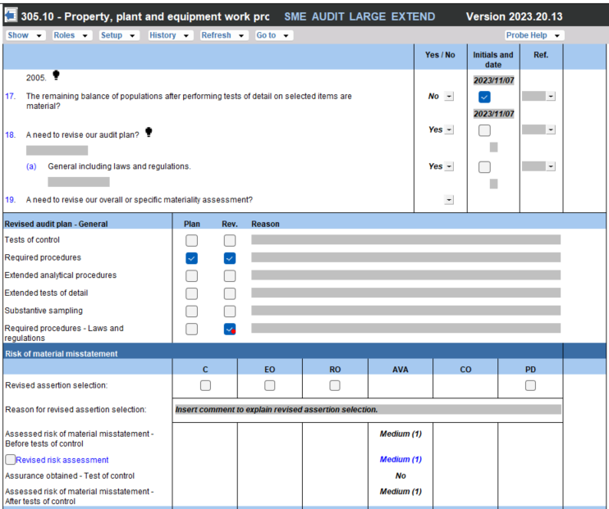

Manager checklist

Manager will be prompted to “Did you review the audit programs to ensure that sufficient appropriate evidence regarding compliance with laws and regulations that may have a direct effect on the determination of material amounts and disclosures will be obtained?”

Testing compliance with Value Added Taxation Act (South Africa)
Read with content of par 4.3.4. In the 2022 and prior releases, the AVA assertion was assigned, in most instances, to the audit procedures testing compliance with acts (hereafter referred to as compliance procedures), except for the Companies Act (to be addressed in the next section). When the audit team identify and assess assertions other than AVA as the relevant or selected assertion for a COTAB, the audit procedures related to AVA will not be included in the work programs. Therefore, when AVA for a material COTAB is not selected, the compliance procedures related to the VAT Act, which may have a direct effect on the determination of material COTABD, will not be included in the work programs.

To address the above scenario, the following changes were made with regards to compliance procedures related to the VAT Act (which in most instances were sub-procedures):
- Moved the procedures from the existing main procedure to a new VAT main procedure.
- Removed any assertions assigned to these compliance procedures.
- Added an affix (ISA 240.14) after the procedures to ‘inform’ users that these procedures relate to testing compliance with laws and regulations of a material COTABD.

These compliance procedures will always be included in a work program for a material COTABD and a COTABD with a relevant assertion.

Testing Compliances with Companies Act (South Africa)
Read with par 4.3.1

In the 2022 release, compliance procedures related to the Companies Act were either included in 18.10 Financial Statement Preparation and/or the relevant work program, for example 805 Capital or contributions. In some instances, there were duplication.

To address the above scenario, the following changes were made to the compliance procedures related to the Companies Act:

- Include the compliance procedures based on the following principles:

  - When the requirements relate to a specific transaction, for example issue of shares or financial assistance to directors, related or interrelated entities or persons, include it in the work program the transaction relates to, for example 805 Capital or contributions or 347 Loans to Group Companies, respectively. Therefore, the compliance procedures will be included for a material COTABD and a COTABD with a relevant assertion.
  - When the requirements relate to presentation or disclosure requirements of the Companies Act, for example directors’ remuneration, include it in 18.10 Financial Statement Preparation. These compliance procedures will always be completed.
  - When the requirements do not relate to a specific transaction, for example the requirements related to the Audit or Social and Ethics Committee, include it in a new work program 20.10 Laws and regulations (NEW).

- Removed any assertions assigned to these compliance procedures.
- Include an affix (ISA 240.14) after the procedures to ‘inform’ users that these procedures relate to testing compliance with laws and regulations of a material COTABD. Except for the compliance procedures included in the new work program since the objective of the new work program is to test compliance with the provisions of laws and regulations.

Please take note that the decisions taken with regards to inclusion of compliance procedures, both those related to the VAT and Companies Act, were presented to, and confirmed by the Content Owner Forum, consisting of audit specialists and customer representatives.

Disclosure items
Section 850 Related parties, Section 857 Commitments and contingencies, Section 880 Statement of Cash Flows, and Sections 891-893 Other disclosure 1-3 refers. When the user selects in 11.60 that these sections are material, the red warning “Select at least one assertion for the material financial statement item (ISA 330.18)” will now appear in these sections in 12.20 Audit plan and strategy to remind the auditor to select the PD assertion.

Going concern conclusion – insufficient audit evidence

02.20 Going concern conclusion
The conclusion on 02.20 related to conclusion option ‘Did not obtain sufficient appropriate audit evidence regarding management’s use of the going concern basis of accounting and management is unwilling to extend its assessment’, has been expanded. In the 2022 and earlier market version, when user selected the above option, the proposed opinion said “'Complete 02.50 and conclude whether a qualified opinion or a disclaimer of opinion is appropriate (ISA570.24)”.

The users can now select between the following two options related to the above scenario:

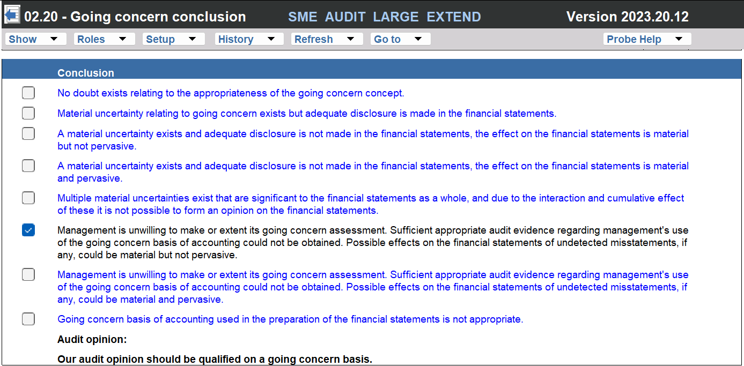

Based on the selection either a qualified or a disclaimer of opinion will be proposed.

02.50 Consideration of assurance reports
To include all relevant qualifying questions that may impact the assurance report, going concern questions based on the conclusion selected on 02.20 will be added to 02.50. The answers to these questions will be automated based on the selection in 02.20, with a hyperlink added to 02.20 in the “Detail” column. There is no duplication of effort, with improved visibility.

Using the scenario in the screenshot in par 4.4.1 above as an example, when the engagement team elected on 02.20 “Management is unwilling to make or extent its going concern assessment. Sufficient appropriate audit evidence regarding management's use of the going concern basis of accounting could not be obtained. Possible effects on the financial statements of undetected misstatements, if any, could be material but not pervasive.”, qualifying question 14 (refer to screenshot below) will appear, with the answer pre-populated. The proposed opinion will be “Qualified opinion” and the “Modified opinion” section will be activated.

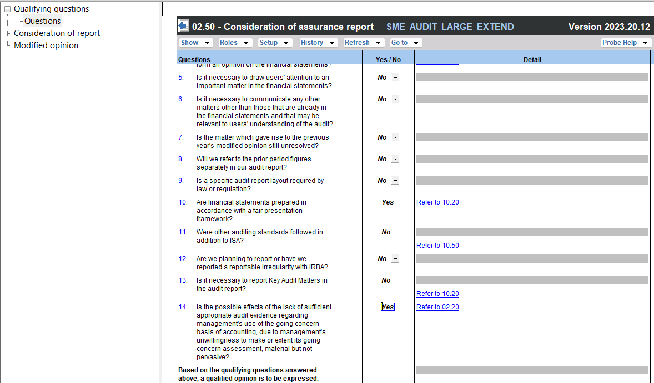

IAS 1
Probe Audit has been updated to address the amendments to IAS1 that require that entities disclose material accounting policy information rather than their significant accounting policies, coming into effect for annual periods beginning on or after 1 January 2023.

Matter identified | ISA ref | Comment
18.10 Financial statement preparations
Accounting policies |  | Procedures were updated and added to test compliance with IAS1 (revised).
Work programs
Presentation and disclosure procedure |  | Procedures were added to test compliance with IAS1 (revised).

Supplementary or other unaudited information
Matter identified | ISA ref | Comment
10.50 Gathering information
Supplementary or other information | ISA700.53  ISA720 | Separate questions are asked to determine whether the entity will present supplementary or other information.  These questions will impact inclusion of procedures on 18.10 Financial statement preparation and 02.50 Consideration of assurance reports.  The term ”other information” is now consistently used in the product. In some instances the term “other unaudited information” was used.
18.10 Financial statement preparation
Supplementary or other information | ISA700.53  ISA720 | On 18.10 in section “"Supplementary information and other information in documents containing audited financial statements" procedures will be added as follows:  • Supplementary information will be included when the question related to supplementary information in 10.51 is answered “Yes”.  - Other information will be included when the question related to other information in 10.51 is answered “Yes”.
02.50 Consideration of assurance reports
Supplementary or other information | ISA700.53  ISA720 | Two questions will be included, one related to other information and another related to supplementary information
Other information | ISA700.53  ISA720 | The answer related to “Other information” captured on 10.50 will pull through to 02.50.  When answered “yes” the section “Other information” that provides procedures related to the required content in the auditor’s report (ISA720.22), will be activated.
Supplementary information |  | The user should answer whether supplementary information is an integral part of the financial statements, based on their evaluation done in 18.10.  When answered “yes” the sub procedure “Covers all supplementary information that is not required by (framework) but is still an integral part of the financial statements due to its nature or presentation (ISA700.52-53)” is added to section “Consideration of report”  When answered “No” the section “Other information” is activated.

Other
Matter identified | ISA ref | Comment
10.20 Engagement evaluation
Reportable institutions |  | Removed the question. As a consequence of the inclusion of high-value goods dealers as a category of accountable institutions, items under Schedule 3 to the Financial Intelligence Centre (‘FIC’ Act) were removed. Schedule 3 included motor vehicle dealers and Kruger rand dealers as reporting institutions.
Accountable institutions |  | Amendments to the FIC Act include an increase in the number of sections included as accountable institutions in Schedule 1 of the FIC Act. Due to the widening of the scope of activities of businesses under Schedule 1, the type of institutions were removed.
10.50 Gathering of information
Was any financial assistance provided for the subscriptions of securities of the company? |  | Question was removed from 10.50 and added to 850 Capital on 10.51.

Probe Work programs
Various changes have been made to the work programs and procedures based on valuable feedback from customers. Some of the key changes include:
- Included new procedures
- Added and removed assertion allocations
- Updated the wording of procedures.
- Updated visibility conditions for when procedures show based on:
- Small and large selection in 10.20.
- Legal form of the entity selected in 10.20.
- Country selected in 10.20.
- Accounting framework selected in 10.20.
- Entity specific selections in 10.50.
- Types of transactions selected in 10.51.
- Sections and relevant TRABs
- Updated extended tests of detail and sampling procedures with procedure numbering and extend step references.

Review

ISQM2 Engagement Quality Reviews
Refer to paragraph 4.2 above.

With regards to “Engagement Quality Review – Planning”, an equivalent of 12.40 has been included as 10.80 Engagement Quality Review – Planning since section 12 is not applicable to Review.

Going concern conclusion – insufficient evidence
Refer to paragraph 4.4 above.

Compilation

No changes were made to Compilation in this release.

Updated document summary
The following documents will work as follow on the update of firm templates from the previous market release as well as engagement files:

Number | Name | Type | Update in this version | Retain data | Retain some data
Firm template set-up
FIRMSETT | Probe Firm Settings | Checklist | a | a
Q | CaseWare Q | Checklist |  | a
Financial statements
Financial statement schedules and minutes
01.60 | Minutes | Letter | a |  | a
Compilation engagement
Finalisation
06.00 | Practitioner sign-off | Checklist |  | a
06.10 | Compilation letter of representation | Letter |  | a
Pre-engagement planning
06.20 | Compilation engagement evaluation | Checklist |  |  | a
06.21 | Compilation engagement letter | Letter
06.50 | Gathering compilation information | Checklist |  | a
Leadsheets and work programs
07.300 | Non-current assets compilation program | Work program |  |  | a
07.400 | Current assets compilation program | Work program |  |  | a
07.500 | Non-current liabilities compilation program | Work program |  |  | a
07.600 | Current liabilities compilation program | Work program |  |  | a
07.700 | Income and expenditure compilation program | Work program |  |  | a
07.800 | Equity compilation program | Work program |  |  | a
07.850 | Other disclosures compilation program | Work program |  |  | a
Engagement working papers
Finalisation
02.00 | Partner sign-off | Letter | a
02.05 | Engagement team declaration | Checklist
02.10 | Subsequent events work program | Checklist
02.20 | Going concern conclusion | Checklist | a
02.22 | Subordination agreement work program | Work program |  | a
02.30 | Overall analytical review | Letter | a |  | a
02.40 | Evaluation of misstatements | Checklist |  |  | a
02.50 | Consideration of assurance report | Checklist | a
02.55 | Key audit matters | Checklist | a | a
02.60 | Senior's final checklist | Checklist | a
02.70 | Manager's final checklist | Checklist | a | a
02.80 | Engagement Quality Review – Execution and finalisation | Checklist | a |  | a
Client communication
02.90 | Report to management and those charged with governance | Work program |  | a
02.92 | Letter of representation | Letter |  | a
Engagement working papers
Pre-engagement planning
10.20 | Engagement evaluation | Checklist | a | a
10.21 | Engagement letter | Letter | a
10.30 | Discussions with those charged with governance | Checklist | a | a
10.40 | Time budget | Letter |  | a
10.50 | Gathering information | Checklist | a | a
10.51 | Types and volumes of transactions | Checklist | a |  | a
10.51IDEA | Types of transactions and terminology | Checklist | a
10.52 | Preliminary analytical review | Checklist | a | a
10.53 | Understanding of accounting estimates | Checklist | a | a
10.55 | Understanding the information Technology environment (IT) | Checklist | a |  | a
10.60 | Overall materiality assessment | Checklist | a | a
10.70 | Identify material items and areas likely to be misstated | Checklist |  | a
10.80 | Engagement Quality Review – Planning (Review) | Checklist | a | a
Planning and risk assessment procedures
11.10 | Risk analysis summary | Checklist |  | a
11.20 | Inherent risk assessment | Checklist | a | a
11.21 | Laws and regulations | Checklist | a
11.25 | Fraud risk assessment | Checklist | a | a
11.30 | Evaluation of system of internal control | Checklist | a | a
11.50 | Information system and control activities | Checklist | a | a
11.60 | Risk assessment at assertion level | Checklist | a
Audit planning
12.10 | Manager planning checklist | Checklist | a
12.20 | Audit plan and strategy | Checklist | a | a
12.21 | Using internal audit | Checklist | a | a
12.22 | Use of resources | Checklist | a | a
12.25 | IDEA sampling | Checklist |  |  | a
12.26 | Use of another practitioner | Checklist | a
12.30 | Planning memorandum | Checklist | a | a
12.40 | Engagement Quality Review – Planning (Audit) | Checklist | a | a
12.50 | IDEA selection | Checklist
Lead sheets and working papers
General working papers
15.10 | Focused enquiries working paper | Checklist | a | a
16.10 | Accounting records work program | Work program | a |  | a
17.10 | Opening balances and comparatives work program | Work program | a |  | a
18.10 | Financial statement preparation work program | Work program | a |  | a
19.10 | General IT controls work program | Work program | a | a
20.10 | Laws and regulations work program | Work program | a |  | a
300. Non-current assets
305. Property, plant, and equipment
305.10 | Property, plant and equipment work program | Work program | a |  | a
306. Right-of-use assets
306.10 | Right-of–use assets work program | Work program | a |  | a
311. Investment property on the cost model
311.10 | Investment property on the cost model work program | Work program | a |  | a
312. Investment property at fair value
312.10 | Investment property at fair value work program | Work program | a |  | a
316. Biological assets on the cost model
316.10 | Biological assets on the cost model work program | Work program | a |  | a
317. Biological assets at fair value
317.10 | Biological assets at fair value work program | Work program | a |  | a
320. Intangible assets
320.10 | Intangible assets work program | Work program | a |  | a
321. Goodwill
321.10 | Goodwill work program | Work program | a |  | a
326. Investments in subsidiaries
326.10 | Investments in subsidiaries work program | Work program | a |  | a
327. Investments in associates
327.10 | Investments in associates work program | Work program | a |  | a
328. Investments in joint ventures
328.10 | Investments in joint ventures work program | Work program | a |  | a
331. Prepayments
331.10 | Prepayments work program | Work program | a |  | a
340. Loans receivable (at amortised cost)
340.10 | Loans receivable (at amortised cost) work program | Work program | a |  | a
341. Debt instruments at FV through OCI
341.10 | Debt instruments at FV through OCI work program | Work program | a |  | a
347. Loans to group companies
347.10 | Loans to group companies work program | Work program | a |  | a
348. Loans to stakeholders
348.10 | Loans to stakeholders work program | Work program | a |  | a
350. Other financial assets
350.10 | Other financial assets work program | Work program | a |  | a
351. Investments at fair value
351.10 | Investments at fair value work program | Work program | a |  | a
352. Derivatives - asset
352.10 | Derivatives – asset work program | Work program | a |  | a
355. Finance lease receivables
355.10 | Finance lease receivables work program | Work program | a |  | a
356. Operating lease assets
356.10 | Operating lease assets work program | Work program | a |  | a
375. Contract assets
375.10 | Contract assets work program | Work program | a |  | a
376. Contract costs
376.10 | Contract costs work program | Work program | a |  | a
380. Retirement benefit asset
380.10 | Retirement benefit asset work program | Work program | a |  | a
390. Other assets
390.10 | Other assets work program | Work program | a |  | a
395. Deferred tax asset
395.10 | Deferred tax asset work program | Work program | a |  | a
396. Municipal deposits
396.10 | Municipal deposits work program | Work program | a |  | a
400. Current Assets
405. Inventories
405.10 | Inventories work program | Work program | a |  | a
405.11 | Attendance at physical inventory count work program | Work program | a |  | a
420. Cash and cash equivalents
420.10 | Cash and cash equivalents work program | Work program | a |  | a
420.11 | Cash count work program | Work program | a |  | a
430. Trade and other receivables
430.10 | Trade and other receivables work program | Work program | a |  | a
432. Construction contracts and receivables
432.10 | Construction contracts and receivables work program | Work program | a |  | a
449. Loans to directors, managers and employees
449.10 | Loans to directors, managers and employees work program | Work program | a |  | a
495. Current tax receivable
495.10 | Current tax receivable work program | Work program | a |  | a
499. NCA held for sale and disposal groups assets
499.10 | NCA held for sale and disposal groups asset work program | Work program | a |  | a
500. Non-current liabilities
515. Provisions
515.10 | Provisions work program | Work program | a |  | a
531. Deferred income
531.10 | Deferred income work program | Work program | a |  | a
542. Compound instruments
542.10 | Compound instruments work program | Work program | a |  | a
545. Redeemable members contributions
545.10 | Redeemable members contributions work program | Work program | a |  | a
547. Loans from group companies
547.10 | Loans from group companies work program | Work program | a |  | a
548. Loans from stakeholders
548.10 | Loans from stakeholders work program | Work program | a |  | a
550. Financial liabilities
550.10 | Financial liabilities work program | Work program | a |  | a
551. Borrowings
551.10 | Borrowings work program | Work program | a |  | a
552. Derivatives - liability
552.10 | Derivatives – liability work program | Work program | a |  | a
553. Financial guarantee contracts
553.10 | Financial guarantee contracts work program | Work program | a |  | a
555. Lease liabilities
555.10 | Lease liabilities work program | Work program | a |  | a
556. Operating lease liability
556.10 | Operating lease liability work program | Work program | a |  | a
575. Contract liabilities
575.10 | Contract liabilities work program | Work program | a |  | a
580. Retirement benefit obligation
580.10 | Retirement benefit obligation work program | Work program | a |  | a
590. Other liabilities
590.10 | Other liabilities work program | Work program | a |  | a
595. Deferred tax liability
595.10 | Deferred tax liability work program | Work program | a |  | a
600. Current liabilities
620. Bank overdraft
620.10 | Bank overdraft work program | Work program | a |  | a
630. Trade and other payables
630.10 | Trade and other payables work program | Work program | a |  | a
688. Dividend payable
688.10 | Dividend payable work program | Work program | a |  | a
695. Current tax payable
695.10 | Current tax payable work program | Work program | a |  | a
699. Liabilities of disposal groups
699.10 | Liabilities of disposal groups work program | Work program | a |  | a
700. Income statement
700. Revenue
700.10 | Revenue work program | Work program | a |  | a
720. Cost of sales
720.10 | Cost of sales work program | Work program | a |  | a
730. Operating income
730.10 | Operating income work program | Work program | a |  | a
741. Operating gains (losses)
741.10 | Operating gains (losses) work program | Work program | a |  | a
750. Operating expenses
750.11 | Wage payout work program | Work program | a |  | a
750.60 | Director's remuneration certificate | Work program | a |  | a
750.10 | Operating expenses work program | Work program | a |  | a
770. Investment income
770.10 | Investment income work program | Work program | a |  | a
775. Finance costs
775.10 | Finance costs work program | Work program | a |  | a
780. Non-operating gains (losses)
780.10 | Non-operating gains (losses) work program | Work program | a |  | a
781. Non-operating expenses
781.10 | Non-operating expenses work program | Work program | a |  | a
785. Non-operating income
785.10 | Non-operating income | Work program | a |  | a
790. Non-controlling interest - IS
790.10 | Non-controlling interest – IS work program | Work program | a |  | a
795. Taxation
795.10 | Taxation work program | Work program | a |  | a
797. Other comprehensive income
797.10 | Other comprehensive income work program | Work program | a |  | a
799. Discontinued operations
799.10 | Discontinued operations work program | Work program | a |  | a
800. Equity
805. Capital or contributions
805.10 | Capital or contributions work program | Work program | a |  | a
810. Retained income
810.10 | Retained income work program | Work program | a |  | a
820. Reserves
820.10 | Reserves work program | Work program | a |  | a
830. Non-controlling interest - BS
830.10 | Non-controlling interest – BS work program | Work program | a |  | a
850. Other disclosures
850. Related parties
850.10 | Related parties work program | Work program | a |  | a
857. Commitments and contingencies
857.10 | Commitments and contingencies work program | Work program | a |  | a
880. Statement of Cash Flows
880.10 | Statement of Cash Flows work program | Work program | a |  | a
891. Other disclosure 1
891.10 | Other disclosure 1 work program | Work program | a |  | a
892. Other disclosure 2
892.10 | Other disclosure 2 work program | Work program | a |  | a
893. Other disclosure 3
893.10 | Other disclosure 3 work program | Work program | a |  | a
900. Probe document templates
90.30 | Controls testing worksheet | Work program |  | a
90.20 | Substantive testing worksheet | Work program |  | a
90.10 | Blank work program | Work program |  | a

Contact Us

Main Contact Details
Adapt IT Reception | +27 10 494 1000

Help Desk Direct Extension
E-mail Caseware Support | support@casewareafrica.co.za

Other Important Details

Register at success.casewareafrica.com for easy access to frequently asked questions, upgrades, downloads, and technical documentation.

Email us at info@casewareafrica.co.za regarding:
Feedback
Ideas on service or products
Product information
Account or license information
Any other queries

Follow us
 | Caseware Africa – South Africa
 | Caseware Africa – South Africa
 | Caseware Africa – South Africa
 | Caseware Africa – South Africa

